Wuthering Heights (1847) by Emile Bronte

Setting: The moors of England – Rugged, Windswept, Solitary
Two Houses - Thrushcross Grange and Wuthering Heights

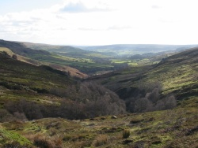

Characters: Two families intertwine in this novel – The Lintons and The Earnshaws

First generation
Heathcliff – Dark, dangerous, full of Angst (adopted son of the Earnshaws)
Hindley Earnshaw
Catherine Earnshaw
Edgar Linton
Isabella Linton

Second Generation
Catherine Linton
Hareton Earnshaw
Linton Heathcliff

Narration:
Lockwood – an outsider who rents the Grange and becomes fascinated with the history of these two families.
Nelly Dean – housekeeper for Mr. Lockwood, tells him much of the story

Style:
The novel is an excellent example of Gothic Literature, which was popular in the late 18th and early 19th centuries. Gothic relies on gloomy settings and an atmosphere of terror and/or mystery to capture the reader’s imagination. Characters tend to be passionate and melodramatic. Supernatural elements frequently make an appearance.

Themes:
Love – as a creative and nurturing force versus love as an all-consuming and destructive force
The destructive power of revenge
The consequences of allowing passion to dominate reason

Symbols/Motifs:
The houses
Natural elements – weather, plants, etc

Follow the link to read about Emily Bronte and the publication of the work:

http://www.penguinclassics.co.uk/nf/shared/WebDisplay/0,,82350_1_10,00.html

